London Underground “What-If” Simulation
User Study Report
Quantitative, qualitative and semantic analysis of questionnaire responses (Sample: n = 21)

Summary
- 21 participants completed a questionnaire after testing the London Underground What-If Simulator.
- Ratings were generally favourable with mean scores between 3.86 and 4.45 on a 5-point scale.
- The What If mode was the most liked feature and was mentioned spontaneously by 8 of the 21 respondents in the open-ended ‘liked most’ question. Quantitatively, it scored among the strongest items (top 2 box, 90.5%) just behind route finding usefulness (95.2%).
- The What If mode is also at the same time the biggest improvement target. 7 respondents reported that the What If mode was hard to find even if they valued it once they found it. This discoverability issue is the main headline finding of the study.
- Other issues centred around dark-mode legibility which had five mentions, the search and routing panel overlap and feature gaps such as the absence of the Elizabeth Line and platform information.
- Sentiment analysis of the open-ended questions corroborates the quantitative pattern: 13 of 21 ‘liked most’ responses scored positive, 20 of 21 ‘bug’ responses were neutral (participants reporting ‘no’/ ‘none’), and improvement responses skewed neutral to negative as expected.

Headline insight: The What If feature is simultaneously the strongest and weakest part of the system. It was loved when found but seemed to be hidden by default. Moving it out from the side drawer to a main UI element is the highest leverage change available.

Background and Methodology
The London Underground What If Simulator is an interactive map-based prototype that supports route finding and lets users simulate disruptions (eg. closing a station) to see how journeys are rerouted. This study evaluated the system with end users using a post task online questionnaire.

Research Questions
- How successfully can participants complete core tasks (route planning, disruption simulation)?
- How do users rate the system on usability, visual clarity, feature usefulness and overall satisfaction?
- Do ratings differ between users with high vs low underground familiarity or between more and less tech savvy users?
- What do participants consider the strongest features and the most pressing improvements?

Instrument
An online Google Forms questionnaire with 26 items: demographic questions (gender, age, Underground familiarity, navigation-app usage, technical background), fifteen 5-point Likert items covering task performance, feature usefulness, visual clarity, usability and overall sentiment, and three open ended questions on positives, improvements and bugs.

Sample
Twenty-one self-selected participants completed the questionnaire between 11 May and 19 May 2026. All confirmed they were aged 18 or older and consented to anonymous use of their responses for research.

Analysis Approach
Likert items were treated as ordinal interval data. For each item we report the mean, median, standard deviation and the proportion of respondents giving a top 2 box rating (4 or 5). One item (‘I required assistance to complete the tasks’) is negatively worded and was reverse coded and this was accounted for. Items were grouped into five themes for reporting clarity. Open ended responses were also coded thematically; a complementary lexicon-based sentiment analysis assigned each response a polarity score based on positive and negative cue words with intensifier and negation handling. Given the small sample, all findings are presented descriptively; no inferential tests are reported.

Participants
The sample skews towards young adults with intermediate technical skills and frequent use of navigation applications. Underground familiarity is well spread. The gender balance is male leaning. The demographic skew is kept in mind when interpreting results. Conclusions are most reliable for the dominant 18–24, app-savvy segment.
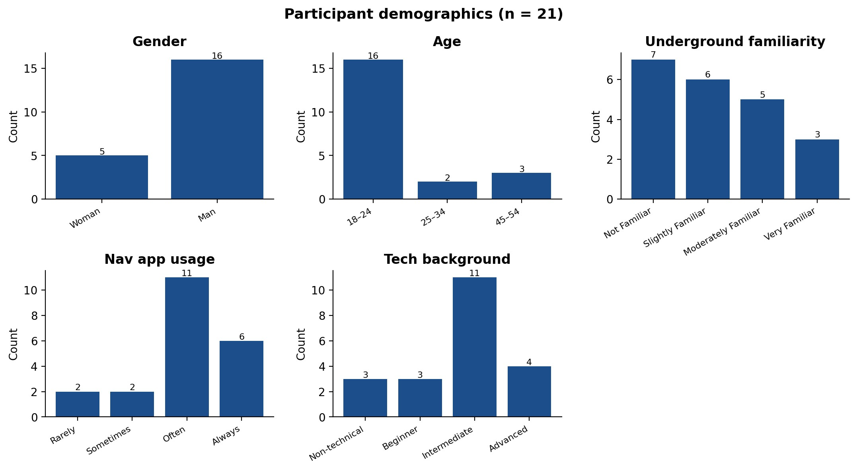
Figure 1. Participant demographic distributions.

Quantitative Findings

Theme Summary
Average ratings across all five themes sit above the scale midpoint with Feature usefulness the highest scoring theme (mean = 4.45/5) and Task performance the lowest (mean = 3.86/5). The Task performance score is dragged down by the reverse-coded ‘assistance required’ item, indicating that while users were able to complete tasks, many felt they needed some help getting there.
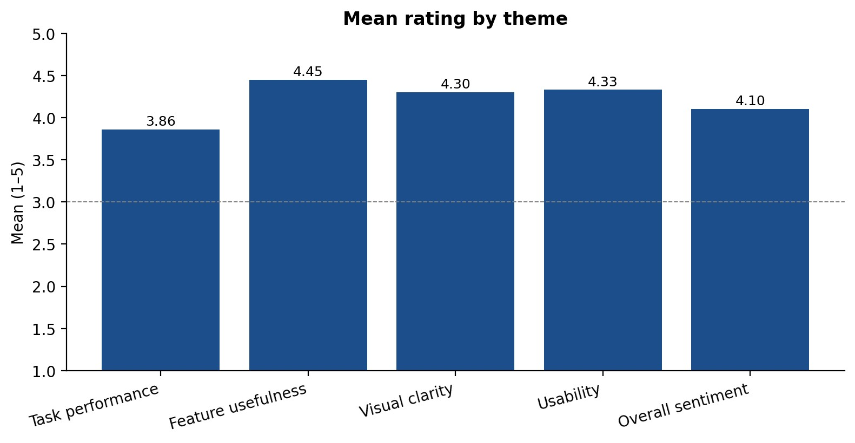
Figure 2. Mean rating by theme (1 = strongly disagree, 5 = strongly agree).

Item-level Descriptive Statistics

Item | Mean | Median | SD | Min |  | Max | Top 2 box %
Task success | 4.38 | 5 | 0.86 |  | 2 | 5 | 86%
Task ease | 4.10 | 4 | 0.94 |  | 2 | 5 | 71%
Assistance needed (reverse coded) | 3.10 | 3 | 1.55 |  | 1 | 5 | 43%
Route finding useful | 4.43 | 5 | 0.75 |  | 2 | 5 | 95%
What If useful | 4.48 | 5 | 0.93 |  | 2 | 5 | 90%
Route info clarity | 4.19 | 5 | 1.03 |  | 2 | 5 | 76%
Line colours helpfulness | 4.14 | 4 | 0.85 |  | 2 | 5 | 81%
Disruption visibility clear | 4.57 | 5 | 0.68 |  | 3 | 5 | 90%
Interface easy | 4.14 | 4 | 0.85 |  | 2 | 5 | 81%
Map controls  intuitive | 4.24 | 4 | 0.77 |  | 2 | 5 | 90%
Responsive | 4.67 | 5 | 0.66 | 3 |  | 5 | 90%
Visually appealing | 4.29 | 4 | 0.72 | 3 |  | 5 | 86%
Uniqueness | 4.19 | 4 | 0.81 | 2 |  | 5 | 86%
Satisfaction | 4.24 | 4 | 0.70 | 3 |  | 5 | 86%
Would use again | 3.86 | 4 | 1.15 | 1 |  | 5 | 71%
Table 1. Descriptive statistics for all Likert items (n = 21). The assistance item is shown reverse-coded so that higher = more positive.

Distribution of Responses
The diverging stacked bar chart below centres each item on its neutral category so that disagreement appears to the left and agreement to the right of the zero line. The What If usefulness item shows the strongest skew towards agreement; Visual appeal and Uniqueness show the largest minority of neutral or negative responses, consistent with the dark mode and font feedback discussed in the qualitative section (section 4).
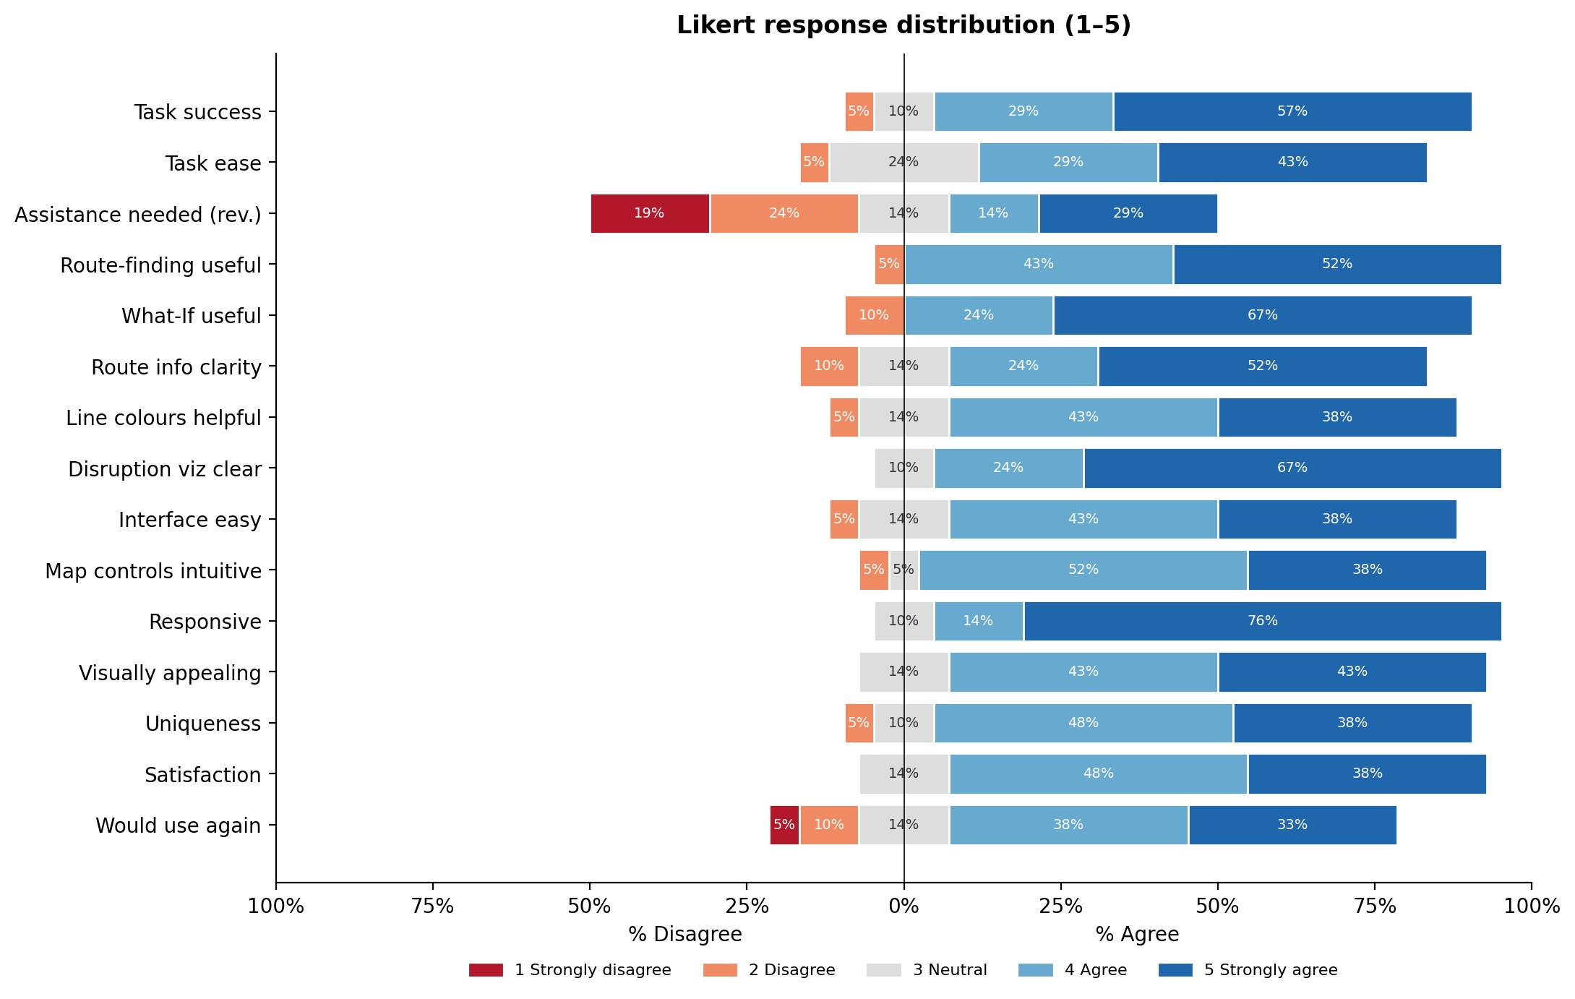
Figure 3. Diverging stacked bar chart of Likert responses for all fifteen items.

Segment Comparisons
Participants were split into two pairs of segments, Underground familiarity (Familiar vs Unfamiliar) and technical background (Tech-savvy vs Less technical) and the top 2 box agreement on each item was compared. Differences are descriptive only given the small subgroup sizes.
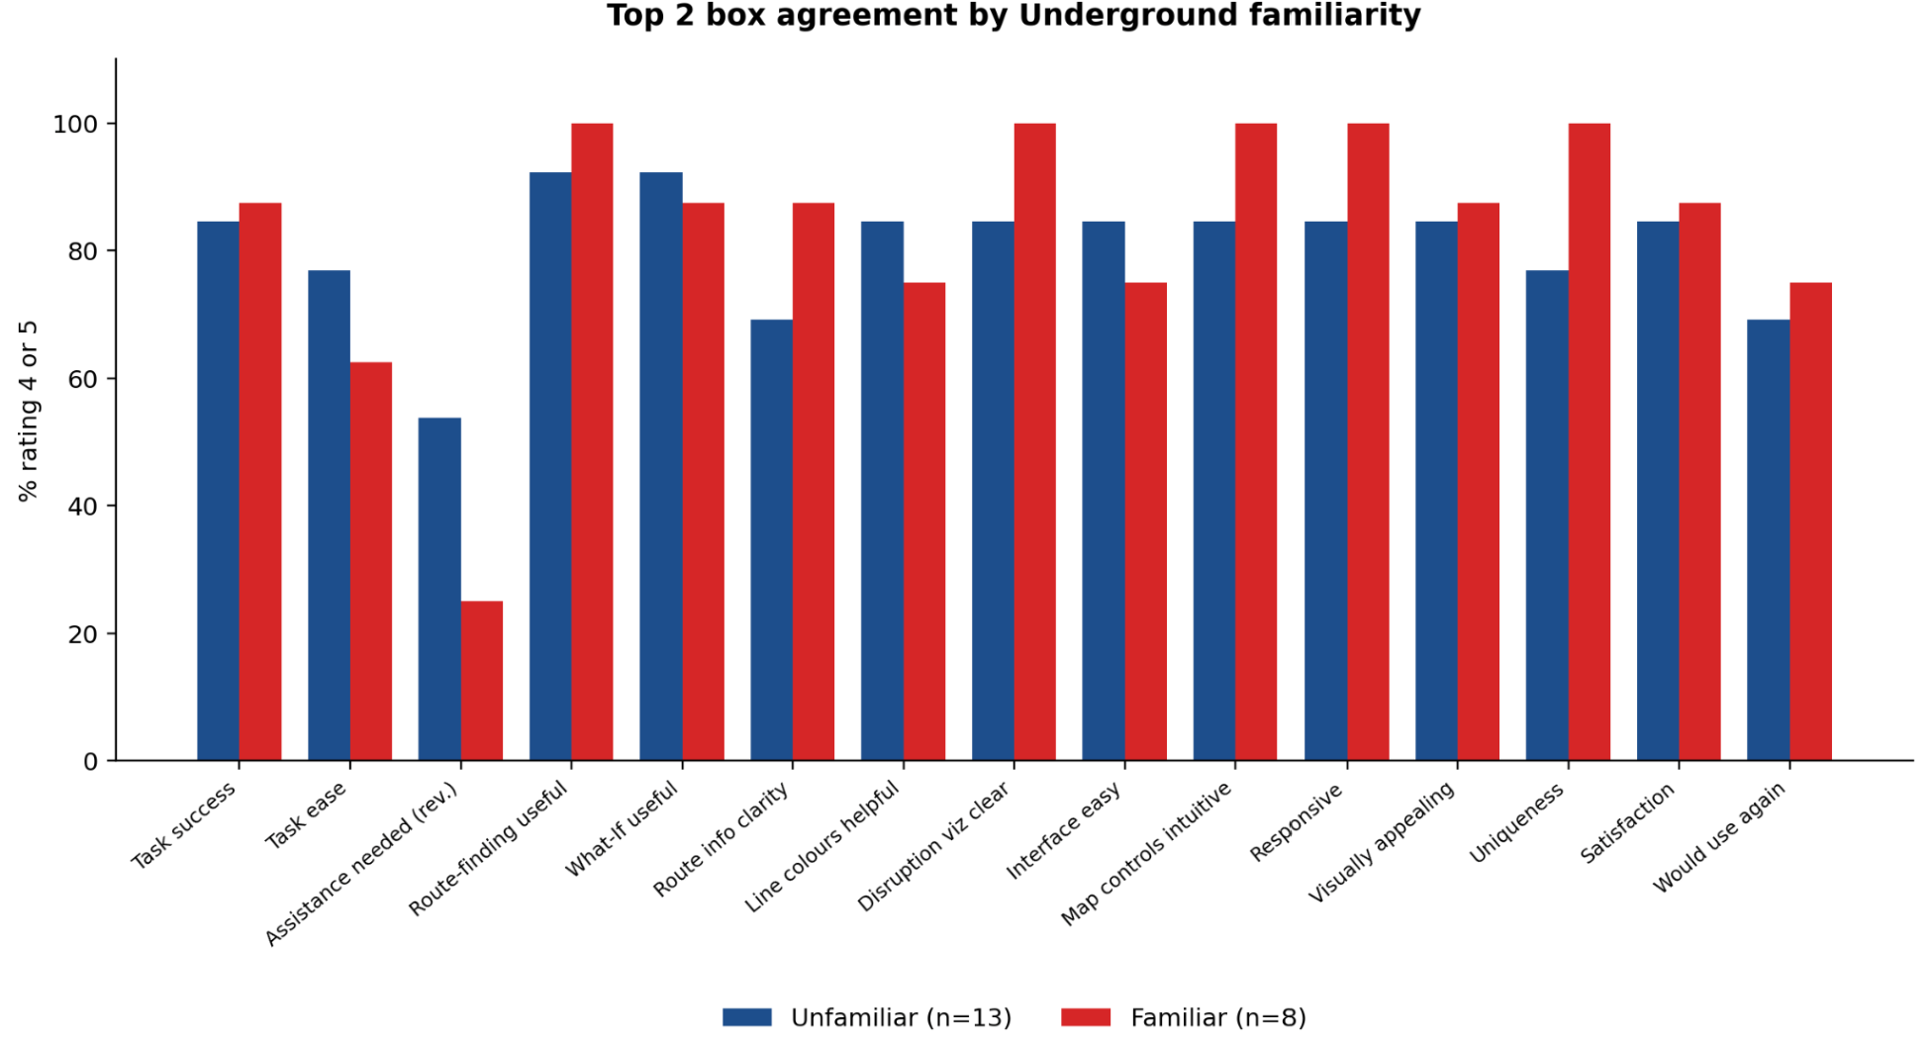
Figure 4. Top 2 box agreement (% rating 4 or 5) by Underground familiarity.
Familiar and unfamiliar users gave broadly similar ratings on most items. The unfamiliar group tended to score the disruption visualisation and route-finding usefulness slightly higher, possibly because they had no prior mental model to compare against. The familiar group was somewhat more critical of visual appeal and uniqueness.
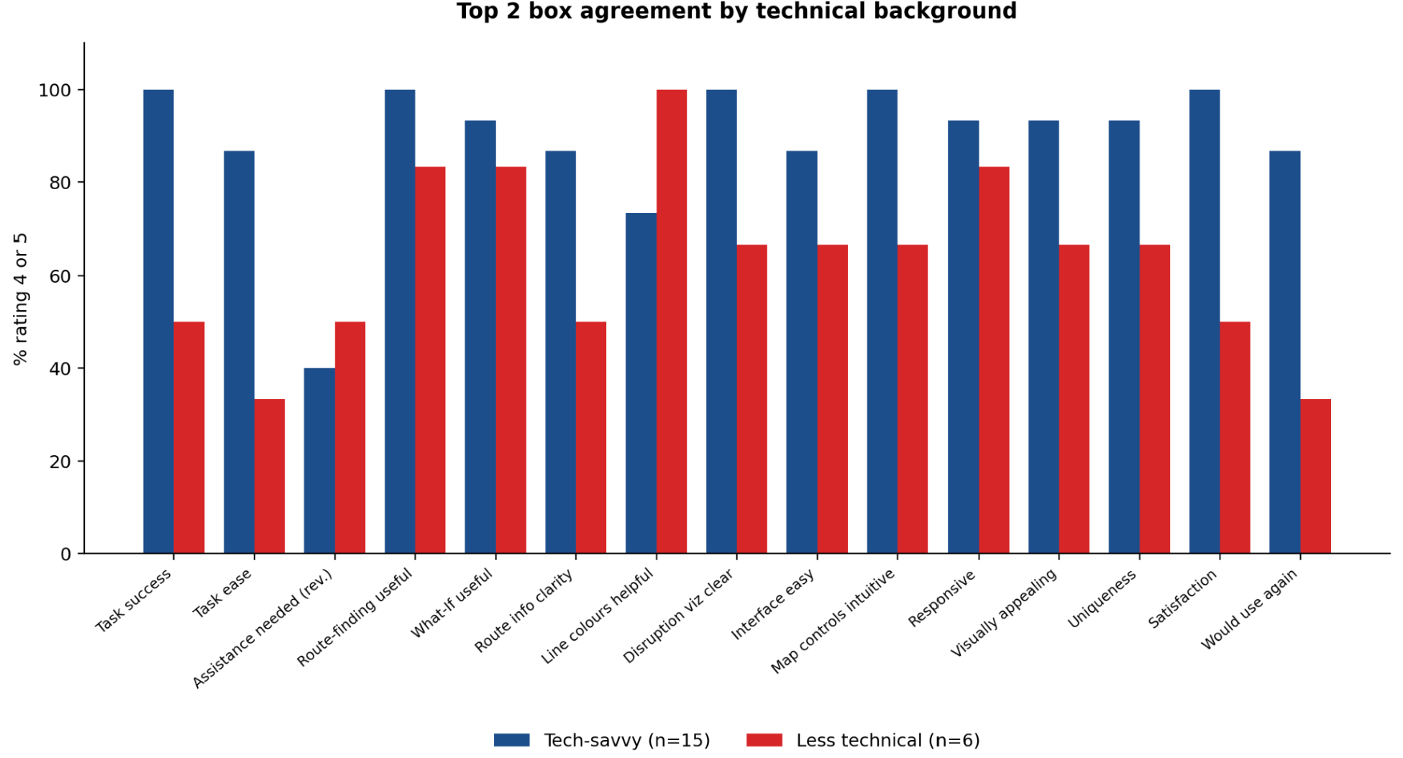
Figure 5. Top 2 box agreement (% rating 4 or 5) by technical background.
Less technical respondents required more assistance and rated task ease lower than tech-savvy respondents, consistent with the open-ended comments about discoverability and onboarding.

Qualitative Findings
All three open-ended questions were coded into themes through close reading. Counts indicate the number of distinct respondents whose response touched on the theme; a single response could touch on more than one theme. Representative verbatim quotes follow each theme cluster.

What Participants Liked Most
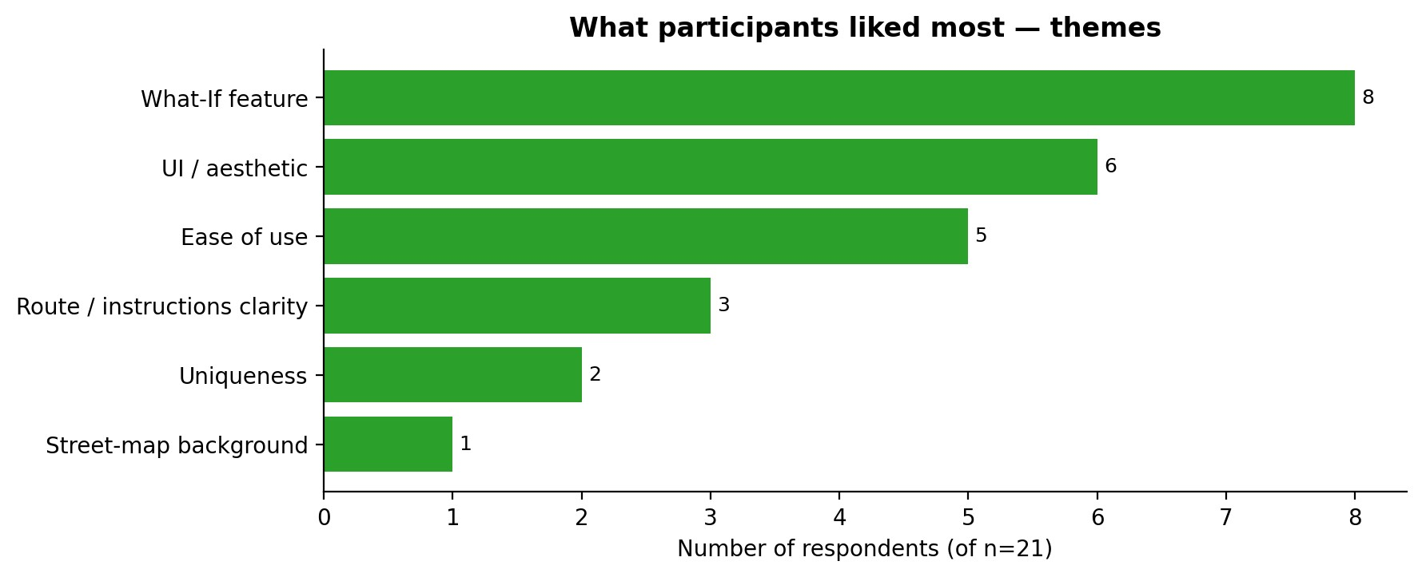
Figure 6. Themes in ‘What did you like most about the system?’
The What If feature was the single most-mentioned positive theme, cited by 8 respondents. UI / aesthetic (6) and ease of use (5) followed.
“The What-If simulator was extremely useful for a very common commuter situation.”
“The “What If” feature allowing you to close a station is incredibly useful.”
“The what if section is cool and i like that you could select the station and it showed you how many stops”
“The What-if Ability”
“What if mode”

Suggested Improvements
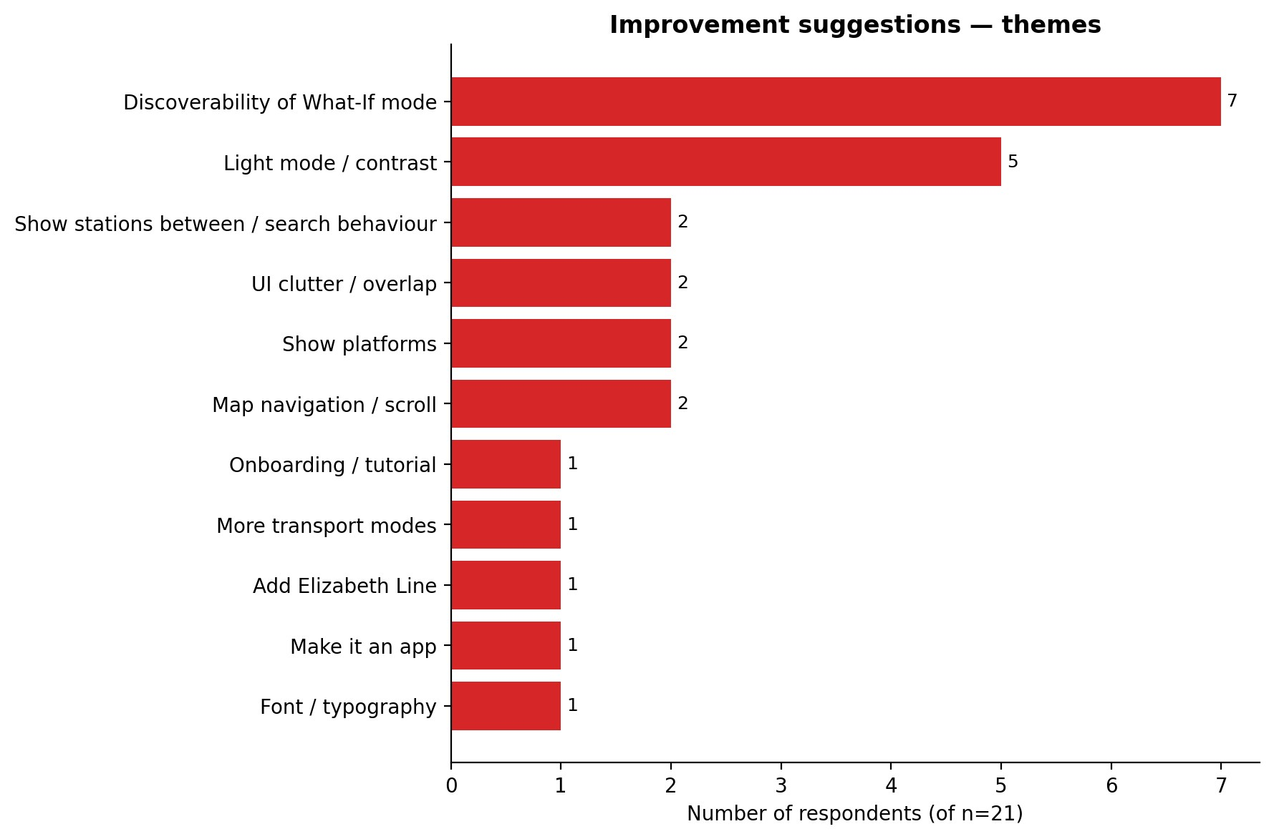
Figure 7. Themes in ‘How could the system be improved?’
Discoverability of the What-If mode dominates the improvement responses with 7 mentions. A light-mode / contrast theme follows (5 mentions). Other recurring themes include UI overlap, map navigation friction and feature gaps (Elizabeth Line, platforms, alternative transport modes).
“clearer instruction where to find the control panel and instructions where to find the what if mode”
“Make the “what if” mode easier to find.”
“I wouldn’t have found the what if pull out tab”
“Central view should be entire map, name of stations is obscured by station dots, what if simulator settings panel not easily identified, also add what platforms to use at the stations. Search and route detail textbox overlap and looks cluttered. After route selection you should centralise the map to see entire route.”
“Make it easier to find what if mode and probably a white background idea of dark and bold writing on navigations with colours so it’s easy to see”

Bugs and Issues
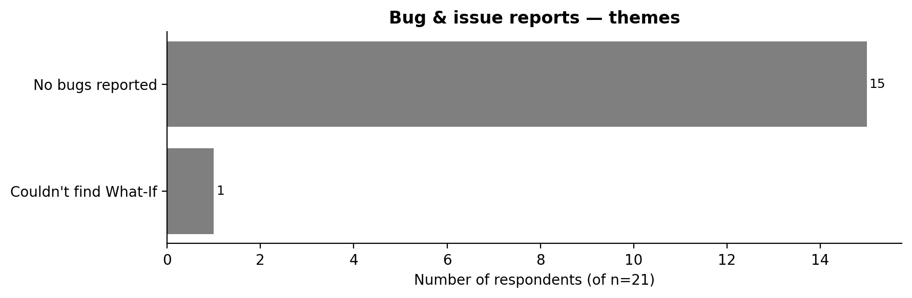
Figure 8. Themes in ‘Did you encounter any bugs or issues during testing?’
Most respondents reported no bugs (15 of 21). The few specific issues mentioned were not classic bugs but interaction-design problems: search/route-detail panel overlap, lost selection when pressing backspace and accidental clears on double-click.

Semantic Analysis
To complement the thematic coding, we ran a sentiment analysis on each free text response. A response was scored using a small lexicon of positive and negative words (eg. love, useful, easy, clear, unique vs hard, confusing, hidden, struggled, tedious), with intensifier (very, extremely) and negation (not, never) handling. Responses with a net positive score were labelled Positive, net negative Negative and zero scores Neutral. Additionally, the most frequent two-word phrases across all open-ended responses were extracted to surface the dominant content terms.

Sentiment Distribution
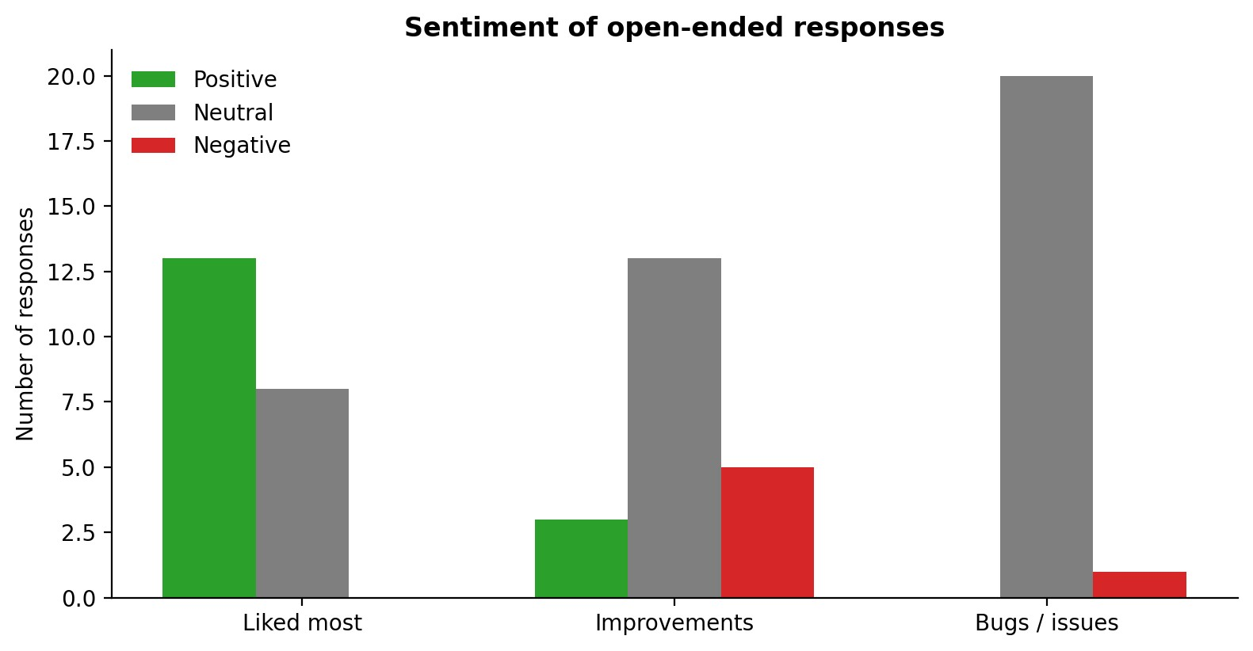
Figure 9. Polarity of open-ended responses by question.
For the ‘liked most’ question, 13 of 21 responses registered as positive and the remainder as neutral, no negative responses, as expected given the prompt. ‘Bugs’ responses were almost entirely neutral (20 of 21), reflecting the dominance of ‘no’/ ‘none’ answers. Improvement responses split between neutral (13) and negative (5) with small positives seen (3) where respondents framed suggestions constructively (eg. ‘It could be cool to have a light mode’).

Dominant Content Terms
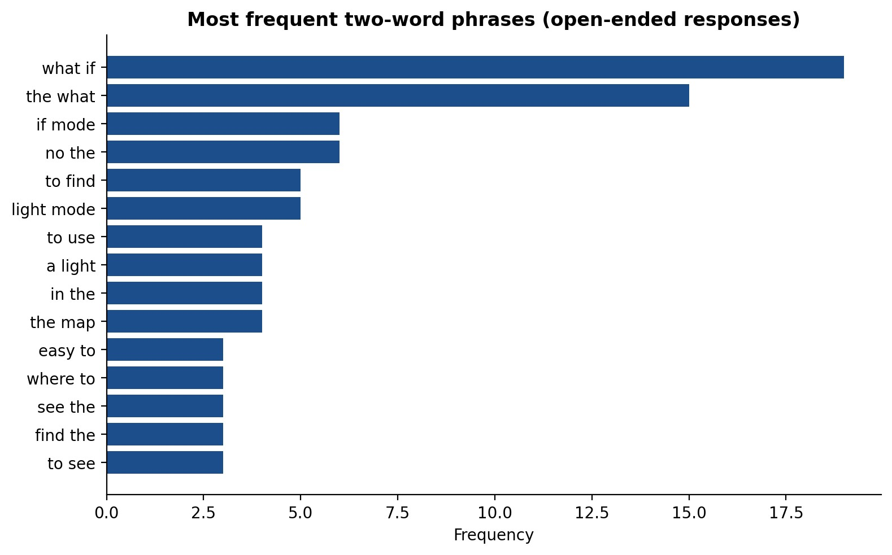
Figure 10. Most frequent two-word phrases across all open-ended responses (after stop-word filtering).
The dominant phrases, ‘what if’, ‘light mode’, ‘easy to’, ‘find the’, reinforce the thematic findings. The repeated co-occurrence of ‘what if’ with verbs such as ‘find’ and ‘easier’ is the linguistic fingerprint of the discoverability problem.

Discussion

The What If issue
The main central, replicated finding across quantitative, qualitative and semantic results is that the What If feature is both the system’s strongest selling point and its most cited usability problem. Quantitatively, the ‘What If is useful’ item is among the strongest rated, with 90.5% top 2 box agreement. Qualitatively, the same feature dominates both the ‘liked most’ and the ‘needs improvement’ theme frequencies. Semantically, the phrase ‘what if’ co-occurs predominantly with positive cue words in the ‘liked’ column and with discoverability cue words (‘find’, ‘easier’, ‘hidden’) in the improvement column. The implication is that the feature works as designed once reached but the entry path is too obscure and hard to get to.

Visual and interaction issues
A secondary finding concerns the dark UI. Five respondents asked for a light mode citing contrast and readability. Several additional comments touch on font choice, panel overlap and slow / tedious map navigation by touchpad. Together these signal that while the aesthetic is well received in the abstract (‘modern’, ‘minimalist’), specific contrast and density choices are hurting use.

Feature gaps
Three specific feature gaps were named by multiple respondents: the Elizabeth Line is missing, platform numbers are not shown, and alternative transport modes (e.g. bus) are not offered. These are not discoverability or interaction design problems; they are scope decisions to revisit.

Recommendations
- Elevating the What if mode within the UI.
Replace the current side-drawer entry point with a visible, persistently labelled control on the main map. Consider an in-map prompt the first time a user completes a route (‘Now try a What-If: what if {station} is closed?’). This is the single highest-impact change indicated by the data.
- Implementation of a light theme.
Five of 21 respondents asked for one. Until then, audit dark-mode contrast ratios for text against the map background, particularly station labels reported as obscured by station dots.
- Refining panel interactions and selection logic.
Address the specific bugs noted: search box vs. route-detail panel overlap, backspace clearing the previously selected station, and double-click clearing start/destination. These are minor in count but have outsized friction.
- Integrated onboarding/tutorial sequence.
A two- or three-step in-product tour, explicitly introducing the What-If feature, would address both the discoverability finding and the ‘intimidating at first’ comment.
- Close the most-named feature gaps.
Add the Elizabeth Line, surface platform information on route steps, and consider showing one alternative transport mode (bus) at minimum for journeys where the Underground is disrupted.
- Centre the map on route after selection.
Auto fit the viewport to the selected route so that the entire journey is visible, addressing the ‘central view should be the entire map’ feedback.

Limitations
- Sample size is small (n = 21) and self-selected; no inferential tests are appropriate.
- Demographics skew heavily towards 18–24-year-olds with intermediate technical skill so findings best generalise to that segment.
- Self-reported task success is not behavioural success; without instrumented logs we cannot verify whether participants who claimed completion took the intended path.
- Sentiment analysis uses a small custom lexicon rather than a trained model, which is transparent but coarse; sarcasm or hedged phrasing may be miscounted.
- Some Likert items (e.g. ‘Uniqueness’) are double-barrelled or interpretive and may carry construct-validity risk.

Appendix A. Theme Coding Inventory

A.1 ‘Liked most’ Themes
Theme | Count (of 21)
What-If feature |  | 8
UI / aesthetic |  | 6
Ease of use |  | 5
Route / instructions clarity |  | 3
Uniqueness |  | 2
Street-map background |  | 1

A.2 ‘Improvements’ Themes
Theme | Count (of 21)
Discoverability of What-If mode |  | 7
Light mode / contrast |  | 5
Show stations between / search behaviour |  | 2
UI clutter / overlap |  | 2
Show platforms |  | 2
Map navigation / scroll |  | 2
Onboarding / tutorial |  | 1
More transport modes |  | 1
Add Elizabeth Line |  | 1
Make it an app |  | 1
Font / typography |  | 1

A.3 ‘Bugs’ Themes
Theme | Count (of 21)
No bugs reported | 15
Couldn't find What-If | 1

